**GITHUB – Updating Lecture Notes**

Before proceeding, make sure that you’ve read the file “GITHUB – Essentials.” Make sure that you’ve committed all outstanding changes.

1. In the top panel go to the “Branch” tab. Click on the option “update from upstream/master”.

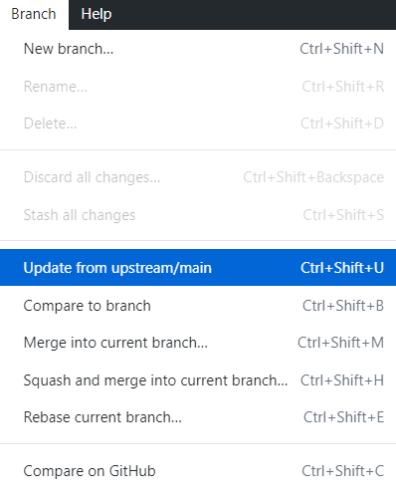

* 1. “upstream” refers to the original repository (the instructor’s)
  2. “master” is usually the name given to the primary version of your repository.

It’s possible to create other intermediate branches where you or your collaborators can work in a change before merging it into the main.

**Practical Advice:**

* Try to do the updating process at the start of every class, to make sure you have the latest version.
* Store any modifications to the files with a separate file name. This avoids your files being overwritten by the instructor’s version when you do this process.
* Privacy: Right now, your forked repository is publicly visible on your account. If you want to change
  + Go to “Github.com”,
  + Gind your forked repository page (in this case “emoryqtm151”)
  + Click on settings
  + Scroll down to the privacy settings and click on the privacy option. You will get a warning and just say yes. The warning is intended to prevent you from making it private if other users are actively drawing information from your repository.